|  |  |
| --- | --- |
| \\cetus.ece.missouri.edu\users\fischerjd\Desktop\Current Semester\common\logo-clear.png | University of Missouri – Columbia  Department of Electrical Engineering & Computer Science |

Solar Powered Lighting System for Outdoor Unpowered Structures

ECE 4980 Capstone Project  
Individual Contributions Report

May 1, 2021

— By —

Sterling LaBarbera, Computer Engineering

— Project Advisors —

Dr. Jae Kwon, PhD

Department of Electrical Engineering & Computer Science, University of Missouri

— Course Instructor —

Mr. Jim Fischer

# Abstract

The project for this paper is a lighting installation for unpowered outdoor structures. Its power source is a battery that charges via solar panel allowing for use at any structure with no main power access. Our intent for this project is to install it permanently at a structure, but it is portable if needed. The lighting is controlled using a Bluetooth capable device with an Android application. It can provide lighting for about four hours using a fully charged battery, and charges back to full in at least 4 days depending on weather. The lighting also features a music mode which takes audio inputs to produce a pulsed output based on volume, one of our main considerations for this project was use in a social event taking place at one of these structures. This paper describes my contributions, which are the power supply units, solar charging unit, and the user interface for the application. The power supply I designed was unsuccessful when integrated. The solar charging equipment was selected to meet the requirements of our project, and the user interface works well and is intuitive and simple.

***Index Terms*—Graphical user interface (GUI), Switched mode power supplies, solar power generation, voltage control.**

Table of Contents

Abstract i

Chapter 1.  Introduction 1

Report Purpose 1

Project Overview 1

Individual Contributions Summary 4

Report Overview 4

Chapter 2.  Contributions 5

2.1 Solar Panel 1BT1 5

2.2 MPPT 1U1 5

2.3 Battery 1BT2 5

2.4 105 W Power Supply 1PS1 8

2.5 10 W Power Supply 1PS2 9

2.6 Smartphone 3U1 LED Output Controls 10

Chapter 3.  Timeline Analysis 12

Proposed Timeline 12

Actual Timeline 12

Chapter 4.  Conclusions 14

Successes 14

Limitations 14

Failures 14

Suggested Improvements 15

Appendix A.  Bill of Materials 16

Appendix B.  Source Code Listings 17

References 20

List of Illustrations

Figure 1. Full project diagram. 2

Figure 2. Functional block diagram for the project. 2

Figure 3.   Software architecture for the CONTROL assembly 2U5 (see also Figure 2). 3

Figure 4. Software architecture for the Smartphone 3U1 (see also Figure 2). 3

Figure 5. The solar panel, MPPT, and battery of unit 1. 7

Figure 6. 105 W power supply 1PS1 with 5.2 VDC output. 9

Figure 7. 7 VDC power supply 1PS2 with connecting wires. 10

Figure 8. Main app screen. 11

Figure 9. App settings screen. 11

Figure 10. MIT App Inventor code blocks part 1. 18

Figure 11. MIT App Inventor code blocks part 2. 19

List of Tables

Table 1. Proposed timeline for phase 1 - development. 12

Table 2. Actual timeline for phase 1. 13

Table 3. Timeline for phases 2 through 4. 13

Table 4. Bill of materials for my contributions. 16

1. Introduction

## Report Purpose

This report documents my contributions to my group’s Capstone design project. Provided herein are detailed descriptions of each assembly and/or software element that I designed, created, tested, and integrated into the project.

A separate group report titled *Solar Powered Lighting System for Outdoor Unpowered Structures* establishes and documents the project-level information that (1) defines the project’s overall concept, specifications, and goals, (2) explains the project’s functionality and theory of operation, (3) describes the evaluation of completed project, and (4) documents the project’s outcomes.

## Project Overview

Figure 1 below shows the full project diagram. The solar panel generates power and sends it to the maximum power point tracker (MPPT). The MPPT sends voltage regulated power to charge the battery or power the connected device. The power supply takes the MPPT output and converts to two different lower voltage outputs for the LED strip and Arduino. These are separate due to current requirements for the strip exceeding the safe values for the Arduino. The Arduino takes inputs from the smart phone via Bluetooth and converts to the digital control signals going to the LED strip.

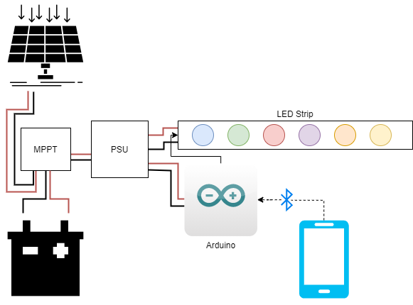

Figure 1. Full project diagram.

Figure 2 shows the functional block diagram for the full project. The parts in green are part of my contribution.

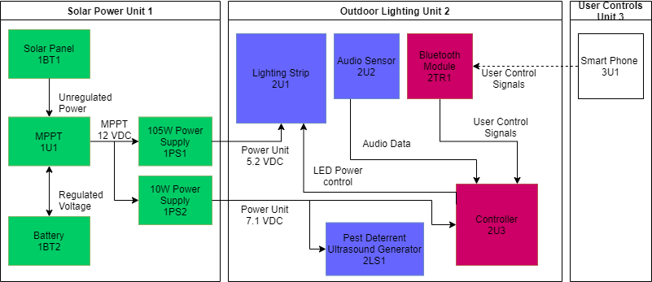

Figure 2. Functional block diagram for the project.

The Solar Panel 1BT1 is 100 W and provides unregulated power to a maximum power point tracker (MPPT) 1U1. The MPPT then regulates that power to 12 VDC to charge the connected Battery 1BT2 and provides the output from the battery for any connected device, in this case, the power supply units (PSU) 1PS1 and 1PS2. The PSUs are switched mode power supplies in parallel. One converts the input to a 5.2 VDC output for the lighting strip 2U1, and the other converts to a 7.1 VDC output for the Controller 2U3. The controller receives input from the user via the Bluetooth module 2TR1 and controls the lights’ brightness and colors. It also receives audio data via the audio sensor 2U2 when in music mode. The pest deterrent ultrasound generator 2LS1 draws power through the controller and produces a high frequency tone to deter certain pests. Finally, the smart phone 3U1 sends user control signals via Bluetooth that are processed by the controller.

Figure 3 and Figure 4 show the software architecture for the microcontroller and smartphone. My contribution is the LED Output Controls

|  |  |  |
| --- | --- | --- |
| Control Assembly – 2U3 | | |
| LED Output Management | | Remote Connection |
| LED Power Control | Audio Data | User Control Signals |

Figure 3.   Software architecture for the CONTROL assembly 2U5 (see also Figure 2).

|  |  |  |
| --- | --- | --- |
| Smartphone – 3U1 | | |
| Mobile Interface | | |
| LED Output Control | Bluetooth Connection Manager | Music Mode |

Figure 4. Software architecture for the Smartphone 3U1 (see also Figure 2).

The control assembly runs on the controller 2U3 and takes user control signals from the application (app) on the smartphone. It is remotely controlled by the smartphone via Bluetooth. The app uses the Bluetooth connection manager to pair with the Bluetooth module on the controller. The LED output controls on the phone provides color controls, brightness adjustment, and 2 different predefined modes of operation which are toggled on and off from the app. Music mode takes audio data and pulses the lights to the music based on volume. Flow mode slowly fades between preset colors. LED power control is the digital output to the LED strip providing control signals for LED brightness.

## Individual Contributions Summary

I worked on Unit 1 which contains the power elements of the project, and the user interface (UI) for the smartphone app. The solar panel 1BT1, MPPT 1U1, and battery 1BT2 were all purchased. I worked on development for power supply 1PS1 to provide the two different constant voltage outputs for controller 2U3 and lighting strip 2U1. For the Mobile Interface, I developed the LED output control which is the UI for the app.

## Report Overview

Following this introduction, Chapter 2 gives a detailed description of my individual contributions to the project including the assumptions made, conception, and theory of operation. Chapter 3 provides a timeline analysis of my contributions comparing the actual dates to the proposed timeline from the first semester. In chapter 4, I summarize the results I obtained and expand on what can be done to improve these elements given more resources. I will also cover the limitations to my approach to the power supply.

The end of this report consists of Appendix A bill of materials, where I give a table of purchased items for my contributions; Appendix B, which contains a code listing for the UI section of the smartphone app; and Appendix C which has the test data from the PSU development. The final element has citations for all the research I used during development.

1. Contributions

In this section, each of my contributions is detailed based on the identification in the functional block diagram.

## 2.1 Solar Panel 1BT1

This was purchased from Amazon and selected to meet our specifications for charging. It is used as-is. We assumed that it would be too difficult to try to construct a solar panel. Since there is a possibility of using the lighting when it is still daytime, I selected a solar panel that could potentially power the system without a charged battery, specifically a 100 W solar panel. The solar panel converts sunlight to electric energy and provides an unregulated power output. The panel is shown in Figure 5.

## 2.2 MPPT 1U1

This was selected from available items in the lab, from previous capstone groups. I selected one the specific one that would support both the solar panel and provide a 12 V output for the battery charging. It also provides a 12 V output line to the power supplies. It is used as-is. The MPPT takes unregulated power from a solar panel and constantly adjusts to regulate it down to a constant 12 V output. It can either charge the battery or directly power a connected device. It is IP-65 weatherproof to comply with our weatherproofing goal. The MPPT is the small box with green lights in Figure 5.

## 2.3 Battery 1BT2

The battery is also purchased from Amazon and used as-is. Based on our functional requirement of 4 hours continuous operation, I calculated the power needed as Amp-hours * Voltage. I selected a 12 V battery since they had generally high capacity and this one was designed for marine or outdoor use. The maximum power for the full system is , and . From these equations, I found the minimum Amp-hours needed as . Due to price restrictions, I chose the closest possible at 36 Amp-hours. While this does not supply enough power for 4 hours operation at full power, we assumed that users would not generally use the lighting at maximum brightness for the full duration. The battery is shown connected with the MPPT in Figure 5. The battery poses an electrical shock hazard as well as a potential fire hazard in a short circuit scenario, as this battery can output high currents.

Figure 5. The solar panel, MPPT, and battery of unit 1.

## 2.4 105 W Power Supply 1PS1

This power supply I originally designed, but my design failed to produce appropriate outputs when connected to the system. The functional requirements specify two outputs, 5.0 ± 0.25 V for the lighting strip 2U1 and 7.1 ± 0.1 V for the controller 2U3, both with a 12 V input. This power supply ended up only being the 5 V output for the lighting strip which must support up to 20 A. This current output has a high risk of electric shock and should not be handled unless disconnected from the MPPT 1U1 when outside its enclosure.

I originally decided to design the power supply since it was difficult to find multiple output supplies that were under $150. I used an online resource to learn about power supply design [1] and found some equations [2] for calculating the component values. I chose a switching frequency of 50 kHz to limit costs on the passive elements. All the appropriate capacitances and inductances needed were calculated using this frequency, a 50% duty cycle, and peak ripple current of 24 A. The basic buck converter circuit is where I started, which uses a high side PMOSFET as a switch between the power supply output and the LC circuit. When on, the inductor and begins storing energy, and when the switch turns off, the inductor releases the energy and turns on a diode to make a full circuit. The capacitor also aids in providing a constant voltage at the output during the on and off cycles as a low-pass filter. Multiple capacitors are used to increase the smoothing of both the output to the load and to smooth the incoming current. Instead of using a high-side switch, I designed my system with a low-side switch to avoid needing a bootstrapping circuit to drive the PMOSFET. With the low-side switch, the battery and the LC circuit have separate grounds, and an NMOSFET changes the voltage of the ground for the LC circuit to alter the current flow. I believe my design failed due to lack of understanding of low-side switching for power supplies, and it may work if I tried to use a high-side switching design instead. As a replacement, I chose a variable input voltage, adjustable output power supply shown in Figure 6. It can handle 20 A output to support the lighting strip and is a switch mode power supply like the one I attempted to design.

Figure . 105 W power supply 1PS1 with 5.2 VDC output.

## 2.5 10 W Power Supply 1PS2

This is a separate assembly instead of a second output since the original design failed. It is purchased from Amazon and used as is and is shown in Figure 7. This power supply has variable input and output voltage, with a maximum 3 A output current. It is also a switch mode power supply. This one takes the 12 V input from the battery and outputs 7.1 V to the controller 2U3 and the Pest Deterrent Ultrasound Generator 2LS1 as specified in the functional requirements.

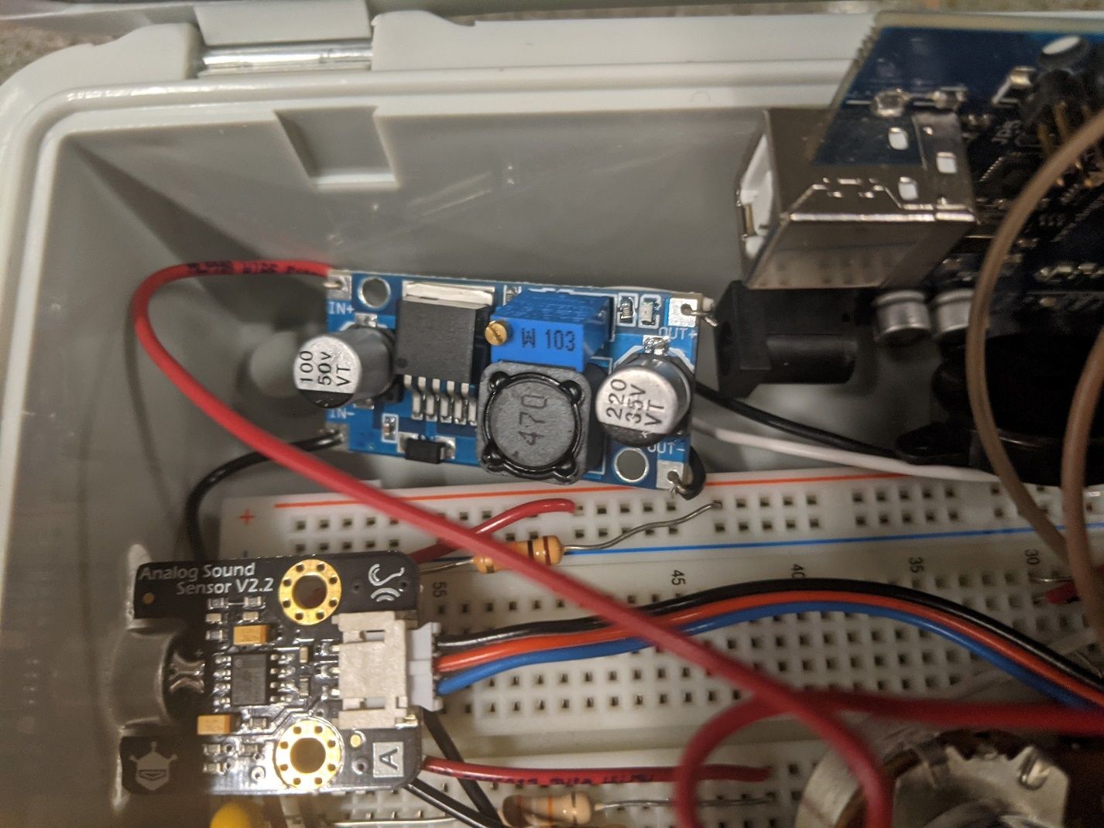

Figure . 7 VDC power supply 1PS2 with connecting wires.

## 2.6 Smartphone 3U1 LED Output Controls

This is the user interface of the App which controls the LED brightness, colors, and modes of operations. The design uses three sliders to control the red, green, and blue LED channels separately. It has buttons to increase and decrease the brightness and two switches which toggle on and off the flow mode and music mode. To achieve our customer goal of usability, all the main controls are clearly labelled and contained on a single screen as shown in Figure 8, and the settings button brings up a separate screen that allows the user to change the audio sensing threshold and the flow mode speed seen in Figure 9.

Figure 8. Main app screen.

Figure 9. App settings screen.

1. Timeline Analysis

This chapter provides an analysis of my deliverable timelines for each phase of the project development.

## Proposed Timeline

|  |  |  |  |  |  |  |  |  |  |
| --- | --- | --- | --- | --- | --- | --- | --- | --- | --- |
| week | 18-Jan | 25-Jan | 1-Feb | 8-Feb | 15-Feb | 22-Feb | 1-Mar | 8-Mar | 15-Mar |
| Element | Phase 1 |  |  |  |  |  |  |  |  |
| Solar Panel, Battery, and MPPT |  |  |  |  |  |  |  |  |  |
| PSU Development |  |  |  |  |  |  |  |  |  |
| Mobile Control - outputs and prefs |  |  |  |  |  |  |  |  |  |
| power supply contingency |  |  |  |  |  |  |  |  |  |

In the proposed timeline in Table 1, I would finish development on 1PS1 by Feb. 19 or purchase the contingency supply. Development on LED Controls software would start on Feb. 8 and be completed by Feb. 26, leaving two weeks of extra time at the end of development phase.

Table . Proposed timeline for phase 1 - development.

## Actual Timeline

In phase one, I ended up working on the power supply development all the way to the end of phase 1, getting a semi-functional power supply, and ordering the contingency after it failed to integrate. This pushed the start of LED Control development back to the final two weeks of development phase and felt somewhat rushed, however the results for the App were successful. The app development also had changes once we integrated it with the other software for the controller 2U3.

|  |  |  |  |  |  |  |  |  |  |
| --- | --- | --- | --- | --- | --- | --- | --- | --- | --- |
| week | 18-Jan | 25-Jan | 1-Feb | 8-Feb | 15-Feb | 22-Feb | 1-Mar | 8-Mar | 15-Mar |
| Element | Phase 1 |  |  |  |  |  |  |  |  |
| Solar Panel, Battery, and MPPT |  |  |  |  |  |  |  |  |  |
| PSU Development |  |  |  |  |  |  |  |  |  |
| Mobile Control - outputs and prefs |  |  |  |  |  |  |  |  |  |
| power supply contingency |  |  |  |  |  |  |  |  |  |

Table . Actual timeline for phase 1.

Table 3 below shows the timeline for the remainder of the semester. I did not vary from this for phases 2 through 4.

|  |  |  |  |  |  |  |  |  |  |  |
| --- | --- | --- | --- | --- | --- | --- | --- | --- | --- | --- |
| week | 15-Mar | 22-Mar | 29-Mar | 5-Apr | 12-Apr | | 19-Apr | | 26-Apr | 3-May |
| Phase 2 - Integration |  |  |  |  |  |  | |  | |  |
| Phase 3 - Demonstration |  |  |  |  |  |  | |  | |  |
| Phase 4 - Evaluation |  |  |  |  |  |  | |  | |  |
| Phase 5 - Presentation |  |  |  |  |  |  | |  | |  |

Table . Timeline for phases 2 through 4.

1. Conclusions

Chapter 4 gives my concluding statements about my contributions to the project. Overall, my contributions ended up being mostly purchased due to the failure of the power supply design, unfortunately, but the app software works well and could be improved more.

## Successes

The LED Controls software worked as intended, providing a convenient and understandable interface for the user to control the lighting. Unit 1 also worked very well and appears to provide more than enough power to run the system for the 4 hours we specified. The battery never died over about 4 hours of on time during testing, with the lowest measured terminal voltage staying at 12.75 VDC.

## Limitations

Since I had no experience coding for Android, I used the MIT App Inventor API, which while convenient, is limited in appearance options for the user interface elements. This did not hamper the usability though. One big limitation on the solar power unit was cost, but we luckily were able to use an MPPT from a previous project getting savings of about $100 of the budget.

## Failures

The power supply design I attempted was primarily to avoid the need for a bootstrap circuit to drive a high side switch. I also mistakenly ordered NMOS transistors only and did not have time to reorder any PMOS transistors after due to time constraints. Overall, the power supply design may have been too far removed from my skill set to implement properly in 8 weeks. It may have had other issues related to materials as well since I used a solderable breadboard and added thicker copper wiring to support the currents.

## Suggested Improvements

I think my contributions would be improved if I had followed my original timeline from the previous semester of stopping the power supply development by February 19 and spending more time on app features, though we only had a limited number of features we could support. The only issues with Unit 1 from a development standpoint were cost limitations based on the amount of power we needed to supply. If I did another project using solar power, I would purchase all the power parts and spend more time on the other aspects. Unique power supply design was an interesting project, but the cost of parts was on par with the price of the adjustable supply I purchased for the contingency.

Bill of Materials

Provided here is the bill of materials for all parts I purchased related to my contributions. They are listed but reference designation from the functional block diagram. Only the parts that are in the demonstrated project are listed here in Table 4. These parts are from Unit 1 and are all purchased off the shelf since the power supplies are the contingency plan.

|  |  |  |  |  |  |  |  |  |  |  |
| --- | --- | --- | --- | --- | --- | --- | --- | --- | --- | --- |
|  | Manufacturer | Manufacturer Part number | Description | Case Style | Distributor | Distributor Part number | Packaging | Qty. | Price per unit $ | Sub-totals $ |
| 1BT1 | Circle 1 Solar |  | 12V 100W Monocrystalline Solar Panel |  | Amazon | B08HRDJR5L | Box | 1 | 99.99 | 99.99 |
| 1BT2 | Might Max Battery | ML35-12 | 12V 35Ah SLA Battery |  | Amazon | B00K8V2VD0 | Box | 1 | 66.99 | 66.99 |
| 1PS1 | Anmbest |  | adjustable DC-DC buck converter | PCB | Amazon | B07R832BRX | box | 1 | 14.99 | 14.99 |
| 1PS2 | Zixtec |  | adjustable DC Buck Converter 10 pack | PCB | Amazon | B07VVXF7YX | box | 1 | 14.99 | 14.99 |
|  |  |  |  |  |  |  |  |  | TOTAL | 196.96 |

Table . Bill of materials for my contributions.

Source Code Listings

In this Appendix, I have provided a screen capture, Figures 10 and 11, of the code blocks from the MIT App Inventor. Slider1 is for red, slider2 is green, and slider3 is blue. Switch1 is music mode, switch2 is flow mode. Button1 and button2 are to increase and decrease the total brightness. ListPicker1 is for selecting the Bluetooth device to pair with. Button3 disconnects from Bluetooth. Button4 opens the settings menu by disabling the visibility of everything on the main page and making the settings sliders visible. Button5 hides the settings and sets the main page visible again. Slider4 changes the flow mode speed, and slider5 changes the volume threshold of the music mode.

Figure 10. MIT App Inventor code blocks part 1.

Figure . MIT App Inventor code blocks part 2.

# References

1. J. Hubner. “Power Supply Design Tutorial.” Pwer Electronics News. https://www.powerelectronicsnews.com/power-supply-design-tutorial/ (retrieved Jan. 28 2021).
2. B. Hauke. “Basic Calculation of a Buck Converter’s Power Stage.” Texas Instruments, Dallas, Texas, United States, SLVA477B, Revised August 2015. Accessed Feb. 22 2021. [Online]. Available: https://www.ti.com/lit/an/slva477b/slva477b.pdf